MESS MANAGEMENT SYSTEM

Project Proposal
V 1.0

By
1 | Muhammad Atif | NUM-BSCS-2025-31
2 | Sadaf | NUM-BSCS-2025-49
3 | Anas Khan | NUM-BSCS-2025-09
4 | Romaisa Maryam | NUM-BSCS-2025-48



Department of Computer Sciences
Namal University
Mianwali, Pakistan
Submission Date : 9th October, 2026
Github: AtifCodes1/Mess-Management-System: Software Engineering semester Project, Project Documents and Reports.
REVISION HISTORY
Date | Version | Description | Approved by
5th October, 2026 | V 1.0 | Changed the requirement provider from Muhammad Arslan, a fourth year Computer Science student to Mr. Naeem Maqbool, Mess Manager. | Ma’am Asiya Batool

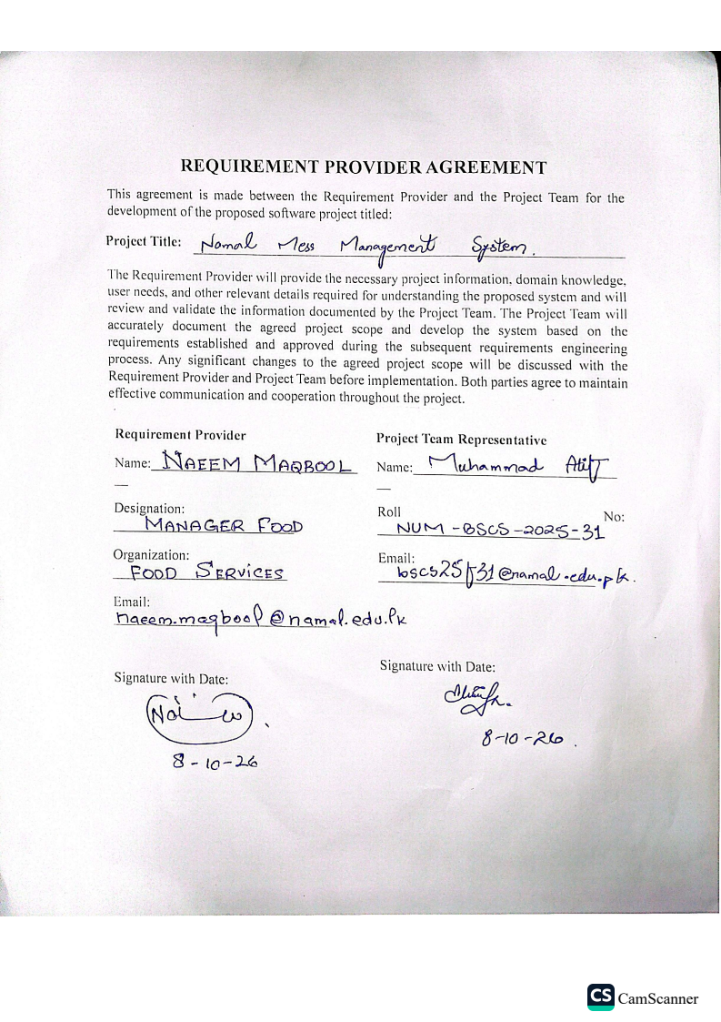
TABLE OF CONTENTS
1. INTRODUCTION:
2. PROBLEM STATEMENT:
3. PROJECT OBJECTIVES:
4. PROJECT SCOPE:
5. STAKEHOLDER IDENTIFICATION: 6
6. SOFTWARE DEVELOPMENT METHODOLOGY: 6
7. TOOLS AND TECHNOLOGIES: 7
REFERENCES 8

INTRODUCTION:
University Mess Management System is designed to make university mess operations fast and easy. It allows students to pre-order their meals online through the website get token with a specific pickup time slot. While the finance team can track all students payments by their accounts for food.
At university, large number of students reach the mess at approximately same time a long queue forms at the mess. The students have to wait in line for the meal because lunch break is limited a lot of students reach late in the next class. As number of students increase in the university there should be software system to handle all crowd and things work smoothly during break time.
This website belongs to the general domain of Mess Management at the campus. It focuses on improving student life facilities by using web technologies to save their time during break time and have things smoothly.
The project aims to develop user friendly website to save students valuable time and streamline university mess operations. It matters to both students and university administration gains complete oversight over mess fee collection have threshold of number of students take meals to benefit in restock system.

PROBLEM STATEMENT:
During lunch time at the university, large number of students arrive at the mess within a limited break period, resulting in long queues at mess. Students waste a lot of time standing in line just to pay or receive their food, which often makes them late for their next classes.
At the same time, mess staff struggle to handle the food quantity crowd within the short period. The current process does not provide students with information about their expected waiting time or their serving turn. Therefore, there is a need for a system that can organise the meal-serving process, distribute students efficiently, and reduce unnecessary waiting time.

PROJECT OBJECTIVES:
- To design a software based queue management system that organises students during the peak lunch hours.
- The system will show menu for the whole week and student can pre-order their meal 1 or 2 hour before the break.
- Every student receive digital token by ordering meal which mention the pickup time ,price and the order that is given.
- An Account for the students where the deposit their money, food payment will be detect from it.
- Students checks their balance, place pre-orders, select pickup slot.
- PROJECT SCOPE:
- Mobile application or notifications so student can receive notifications about pickup time, low balance, and order status.
- QR-code scanning at the mess for faster and more secure meal collection.
- Orders can be analyzed to predict how many meals will be required during different day times.
- Instead of taking food on the current account balance, there will be option to use cards, and other payment methods.
- Similar to large food brands, customers could receive points, discounts, coupons and rewards.
- STAKEHOLDER IDENTIFICATION:
Table 1: Stakeholders and Their Roles in the Proposed System
Stakeholder | Role | Interaction with System
Students | Primary users | Orders meals, select pickup slots, manage their balance
University staff | Users | They also order meal, manage their balance
Mess staff | Workers | Cook, prepare, pack meal according to orders.
Mess Manager | Manager | Manages the mess operations, menus, meal availability, staff activities.
Finance Department | Finance Handling | Handle accounts, recharge, meal charges, financial records.
System Administration | Administrators | Responsible for maintaining and controlling the system.
Inventory Manager | Monitoring | Monitors food ingredients, stock levels, and restocking requirements.
- SOFTWARE DEVELOPMENT METHODOLOGY:
The Agile Software Development Methodology, using a Scrum-based iterative approach, will be followed for the development of the University Mess Management System. Agile is suitable for this project because the system involves multiple stack holders, including students, mess staff, finance personnel.
- Planning: During this phase the development team will identify, the project goals, scope, stakeholders, major features, required resources, and expected timeline.
- Requirement Analysis: The team will gather and analyze requirements from stakeholders, mess manager, finance office, university administration.
- System Design: Based on the analyzed requirements, the team will design the system architecture, database, user interface, and different system modules.
- Implementation: The system will be implemented incrementally during multiple development sprints. The team will first develop the core functionality and then gradually add additional modules.
- Testing: Testing will be performed continuously throughout the development process rather than only at the end.
- Feedback and Change Management: At the end of each sprint, the developed features will be reviewed and feedback will be collected.
- Delivery and Deployment: After all major requirements have been implemented and tested, the complete system will undergo final system testing and user system testing.
- TOOLS AND TECHNOLOGIES:.

We will use the following tools and technologies in our project.
Table 2: Proposed Tools and Technologies
# | Tools and Technology | Purpose
1 | HTML5, CSS3, JavaScript | For the Frontend
2 | Python | Backend
3 | MySQL | Database
4 | Figma | UI/UX Design
5 | Microsoft word | Documentation
REFERENCES
[1] “Scrum Methodology | Agile Scrum Framework | Scrum Master Tutorial,” YouTube, [Online video]. Available: https://www.youtube.com/watch?v=8dGdIcyDk1w. [Accessed: Oct. 9, 2026].

[2] OpenAI, ChatGPT, response to “Which software development methodology is suitable for a University Mess Management System?”, Oct. 9, 2026. [Online]. Available: https://chatgpt.com/ .
[3] Cam Scanner for pdf.

